IdeationPhase

Brainstorm&IdeaPrioritizationTemplate

Date | 1 November2025
TeamID | 69c0be5ec71a9ebd6a51912e
ProjectName | StreamliningTicketAssignmentforEfficient Support Operations
MaximumMarks

Step-1:TeamGathering,CollaborationandSelecttheProblemStatement
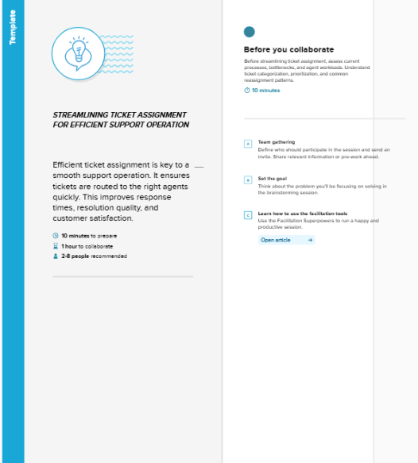

Step-2:Brainstorm,IdeaListingandGrouping
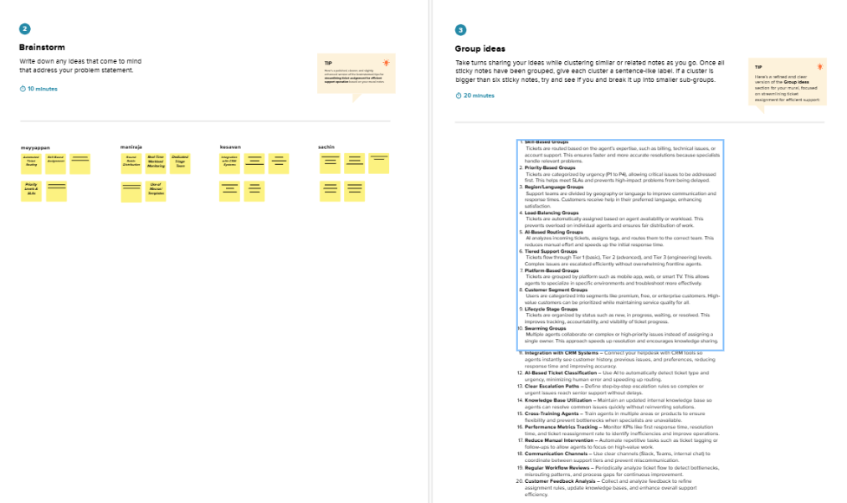
Step-3: IdeaPrioritization

